

**#SNAGS2018**

**2018 Scottish National**

**Age Group Swimming Championships**

**(Under FINA Rules & Scottish Swimming Regulations)**

**Tollcross International Swimming Centre**

350 Wellshot Road, Glasgow G32 7QP

**28th March – 1st April 2018**

**(Licence No: L1/562/WD/MAR18)**



**MEET INFORMATION**

**Contents Page**

Venue Details, Session Times & Programme of Events 3

Schedule of Events 4

Eligibility to Compete 5

Entry Times (Individual Qualifying & Consideration Times) 6 - 7

Entries Information 8

Withdrawal Procedures & General Information 9

Awards & Presentations 10

Coach Information 11

Event Regulations 12

Media and Photography Consent Form 13

**VENUE DETAILS, SESSION TIMES & PROGRAMME OF EVENTS**

**Venue:** Tollcross International Swimming Centre, 350 Wellshot Road, Glasgow G32 7QP, 0141 276 8282

**Pool:** 10 lane x 50 metre (Full electronic timing)

Separate 4 lane x 25m warm-up and swim-down facility

**Promoters:** SASA National Swimming Committee

|  |  |  |  |  |  |  |
| --- | --- | --- | --- | --- | --- | --- |
| **Session times:-** | **Wednesday – Sunday** | Morning | Heats | Warm Up: | 08.00 | NB. Session start times may be adjusted once all entries have been received and processed.  Any new session times will be notified with confirmation of acceptances. |
|  |  | Start: | 09.00 |
| Afternoon | Heats | Warm Up: | 12.40 |
|  |  | Start: | 13.40 |
| Evening | Finals | Warm Up: | 16.25 |
|  |  | Start: | 17.15 |

**INDIVIDUAL EVENTS**

**YOUTH**

|  |  |
| --- | --- |
| **Boys & Girls:**15, 16, 17/18 years, 19/over | Heats swum in the morning sessions |
| 50m, 100m, 200m, 400m Freestyle  50m, 100m, 200m Backstroke  50m, 100m, 200m Breaststroke  50m, 100m, 200m Butterfly  200m, 400m Individual Medley | Heats and Finals |
| 800m, 1500m Freestyle | Heat Declared Winner |

**AGE GROUP**

|  |  |
| --- | --- |
| **Boys & Girls:**11-13 and 14 years | Heats swum in the afternoon sessions |
| 50m, 100m, 200m Freestyle  50m, 100m, 200m Backstroke  50m, 100m, 200m Breaststroke  50m, 100m, 200m Butterfly  200m Individual Medley | Heats and Finals |
| 400m, 800m, 1500m Freestyle  400m Individual Medley | Heat Declared Winner |

**RELAY EVENTS**

**YOUTH**

|  |  |
| --- | --- |
| **Boys & Girls:** 14–16 and 17 years & over | Swum in the morning sessions |
| 4 x 100m Freestyle, 4 x 100m Medley, 4 x 100m Freestyle | Heat Declared Winner |

**AGE GROUP**

|  |  |
| --- | --- |
| **Boys & Girls:** 11-13 years | Swum in the afternoon sessions |
| 4 x 100m Freestyle, 4 x 100m Medley | Heat Declared Winner |

**PLEASE NOTE:**

**This is the ONLY event where Scottish relay teams may qualify for the British Summer Championships.**

**Swimmers aged 19 & over will swim heats only and will be integrated into the 15,16, 17/18 youth events. However, should there be ten or more 19 & over swimmers entered in any event at the end of the withdrawal window of each session, the fastest ten swimmers will swim in a heat of their own. In the event that there are fewer than ten swimmers aged 19 & over at the end of the withdrawal window of each session, a separate heat may be run at the discretion of the Meet Director.**

**For individual and relay events: Age as at 31st December 2018**

**SCHEDULE OF EVENTS**

|  |  |  |  |  |
| --- | --- | --- | --- | --- |
| **Wednesday 28th March 2018** | **Thursday 29th March 2018** | **Friday 30th March 2018** | **Saturday 31st March 2018** | **Sunday 1st April 2018** |
| **Session 1** | **Session 4** | **Session 7** | **Session 10** | **Session 13** |
| ***Warm Up: 08.00 : Start: 09.00*** | ***Warm Up: 08.00 : Start: 09.00*** | ***Warm Up: 08.00 : Start: 09.00*** | ***Warm Up: 08.00 : Start: 09.00*** | ***Warm Up: 08.00 : Start: 09.00*** |
| **Boys & Girls: 15, 16, 17/18 & 19 & over** | **Boys & Girls: 15, 16, 17/18 & 19 & over** | **Boys & Girls: 15, 16, 17/18 & 19 & over** | **Boys & Girls: 15, 16, 17/18 & 19 & over** | **Boys & Girls: 15, 16, 17/18 & 19 & over** |
| Girls 200m Backstroke | Girls 200m Breaststroke | Boys 200m Backstroke | Girls 200m Individual Medley | Boys 200m Individual Medley |
| Boys 100m Backstroke | Boys 200m Butterfly | Girls 400m Freestyle | Boys 200m Freestyle | Girls 200m Freestyle |
| Girls 100m Freestyle | Girls 100m Backstroke | Boys 50m Freestyle | Girls 100m Butterfly | Boys 100m Freestyle |
| Boys 200m Breaststroke | Boys 50m Breaststroke | Girls 50m Freestyle | Boys 100m Butterfly | Girls 100m Breaststroke |
| Girls 50m Breaststroke | Girls 400m Individual Medley | Boys 100m Breaststroke | Girls 50 Backstroke | Boys 50m Backstroke |
| Boys 50m Butterfly | Boys 400m Freestyle | Girls 200m Butterfly | Boys 400m Individual Medley | Girls 50m Butterfly |
| Girls 1500m Freestyle HDW | Girls 14-16 4x100m Medley Relay HDW | Boys 1500m Freestyle HDW | Girls 800m Freestyle HDW | Boys 800m Freestyle HDW |
| Boys 17 & over 4x200m  Freestyle Relay HDW | Girls 17 & over 4x100  Medley Relay HDW | Girls 17/over 4x100m  Freestyle Relay HDW | Boys 17 & over 4x100  Freestyle Relay HDW | Girls 17 & over 4x200  Freestyle Relay HDW |
| Boys 14-16 4x200m  Freestyle Relay HDW | Boys 14-16 4x100 Medley Relay HDW | Girls 14-16 4x100m  Freestyle Relay HDW | Boys 14-16 4x100  Freestyle Relay HDW | Girls 14-16 4x200  Freestyle Relay HDW |
|  | Boys 17 & over 4x100  Medley Relay HDW |  |  |  |
| **Session 2** | **Session 5** | **Session 8** | **Session 11** | **Session 14** |
| ***Warm Up: 12.40 : Start: 13.40*** | ***Warm Up: 12.40 : Start: 13.40*** | ***Warm Up: 12.40 : Start: 13.40*** | ***Warm Up: 12.40 : Start: 13.40*** | ***Warm Up: 12.40 : Start: 13.40*** |
| **Boys & Girls: 11-13 & 14** | **Boys & Girls: 11-13 & 14** | **Boys & Girls: 11-13 & 14** | **Boys & Girls: 11-13 & 14** | **Boys & Girls: 11-13 & 14** |
| Girls 200m Backstroke | Girls 200m Breaststroke | Boys 200m Backstroke | Girls 200m Individual Medley | Boys 200m Individual Medley |
| Boys 100m Backstroke | Boys 200m Butterfly | Girls 400m Freestyle HDW | Boys 200m Freestyle | Girls 200m Freestyle |
| Girls 100m Freestyle | Girls 100m Backstroke | Boys 50m Freestyle | Girls 100m Butterfly | Boys 100m Freestyle |
| Boys 200m Breaststroke | Boys 50m Breaststroke | Girls 50m Freestyle | Boys 100m Butterfly | Girls 100m Breaststroke |
| Girls 50m Breaststroke | Girls 400m Individual Medley HDW | Boys 100m Breaststroke | Girls 50 Backstroke | Boys 50m Backstroke |
| Boys 50m Butterfly | Boys 400m Freestyle HDW | Girls 200m Butterfly | Boys 400m Individual Medley HDW | Girls 50m Butterfly |
| Girls 1500m Freestyle HDW | Girls 11-13 4x100m  Medley Relay HDW | Boys 1500m Freestyle HDW | Girls 800m Freestyle HDW | Boys 800m Freestyle HDW |
| Boys 11-13 4x100m  Freestyle Relay HDW |  |  |  | Girls 11-13 Freestyle Relay  4x100m Freestyle Relay HDW |
|  |  |  |  | Boys 11-13 Medley Relay  4x100m Medley Relay HDW |
| **Session 3 – FINALS** | **Session 6 - FINALS** | **Session 9 – FINALS** | **Session 12 – FINALS** | **Session 15 - FINALS** |
| ***Warm Up: 16:25 : Start: 17:15*** | ***Warm Up: 16.25 : Start: 17:15*** | ***Warm Up: 16:25 : Start: 17:15*** | ***Warm Up: 16:25 : Start: 17:15*** | ***Warm Up: 16:25 : Start: 17:15*** |
| Girls 200m Backstroke | Girls 200m Breaststroke | Boys 200m Backstroke | Girls 200m Individual Medley | Boys 200m Individual Medley |
| Boys 100m Backstroke | Boys 200m Butterfly | Girls 400m Freestyle | Boys 200m Freestyle | Girls 200m Freestyle |
| Girls 100m Freestyle | Girls 100m Backstroke | Boys 50m Freestyle | Girls 100m Butterfly | Boys 100m Freestyle |
| Boys 200m Breaststroke | Boys 50m Breaststroke | Girls 50m Freestyle | Boys 100m Butterfly | Girls 100m Breaststroke |
| Girls 50m Breaststroke | Girls 400m Individual Medley | Boys 100m Breaststroke | Girls 50m Backstroke | Boys 50m Backstroke |
| Boys 50m Butterfly | Boys 400m Freestyle | Girls 200m Butterfly | Boys 400m Individual Medley | Girls 50m Butterfly |
| **Finals will be swum from youngest to oldest age groups** | | | | |

**ELIGIBILITY TO COMPETE**

All competitors must be registered with their National Federation to be eligible to compete (FINA Rule GR 1.1).

To compete for a Scottish Club or Team at National Age Group Championships, competitors must be registered with SASA and must have paid their current registration fee.

Any athlete eligible to represent Scotland in accordance with Company Rules R4.5.3 who is not a member or a club affiliated to SASA, who wishes to be recognised as ‘Scottish’ must register with SASA.

**National Eligibility – Scottish Swimming Company Rule R4.5.3**

R4.5.3 - A competitor selected to represent Scotland must be a registered member of SASA as per SASA Constitution C3.3 or C.3.5.1. and must be either:

* A native of Scotland, **or**
* A person with a Scottish mother or father, **or**
* Satisfy either of the following residential criteria:
  1. For the Commonwealth Games - In line with current Commonwealth Games Federation Regulations or Guidelines (see Commonwealth Games Swimming selection policy for details).
  2. For all other Meets - A person who has been resident in Scotland for a minimum of 6 months in the 12 months prior to the first day of competition. Irrespective of any proposals to change at 2018 SASA AGM.
* Individual Age Group events and Relay events are defined as age at 31st December 2018.
* No more than 3 swimmers who do not qualify as Scottish (see above) will be allowed to progress into any Final.

**Consideration Times (CT)**

May be used by competitors registered with SASA if they:

a) Are competing for a Scottish Club or Team, **or**

b) Qualify for National Eligibility (as defined by Company Rule R4.5.3) and are registered with SASA having paid their current registration fee.

**Qualifying Times (QT)**

Competitors as defined above with an entry time equal to or faster than the **Qualifying Times (QT**) will be guaranteed acceptance (subject to time verification). Entries slower than the Qualifying Time may be restricted in order to manage session lengths.

**Non Scottish Time (Non Scot)**

Entries submitted by all other swimmers must be equal to or faster than the **Non Scottish Time (Non Scot)** These swimmers will be guaranteed entryacceptance (subject to time verification) with the exception of 800m and 1500m events where the Non Scot time will be treated as a consideration time rather than a qualifying time.

All competitors must enter times achieved in accredited competitions held between 9th March 2017 and 9th March 2018 and either be 50 metre pool times or conversions to 50 metre pool times (Official conversion tables: Hy-tek standard conversion or ASA conversion tables may be used).

**Team Entries**

There are no consideration or qualifying times for Relays. Clubs should submit a time based on the individual times of the team members. This will be used for seeding purposes and must be capable of verification. If it is necessary to restrict the number of relay entries, this will be done on the basis of entry time.

**Proof of Entry**

**A proof of entry times report is required in accordance with SW2.1.2.5. Random checks on entry times will be carried out prior to and during the event. Any swimmers submitting an unaccredited entry time will automatically be withdrawn from all entered events and will forfeit all entry fees.**

The organisers reserve the right to restrict entries to ensure a good standard of competition. If it is necessary to reject entries, this will be done on the basis of entry time, slowest to fastest, excluding guaranteed acceptances as detailed above.

**MALE ENTRY TIMES**

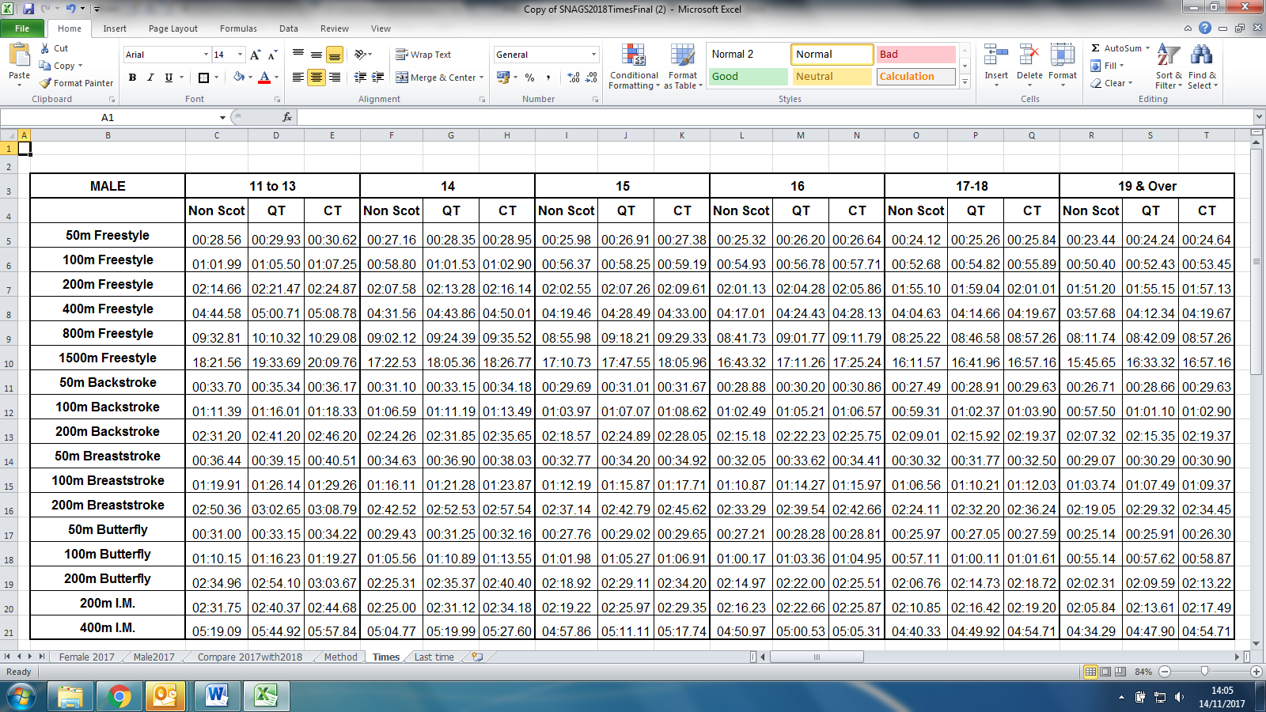

**Age as at 31st December 2018**

**FEMALE ENTRY TIMES**

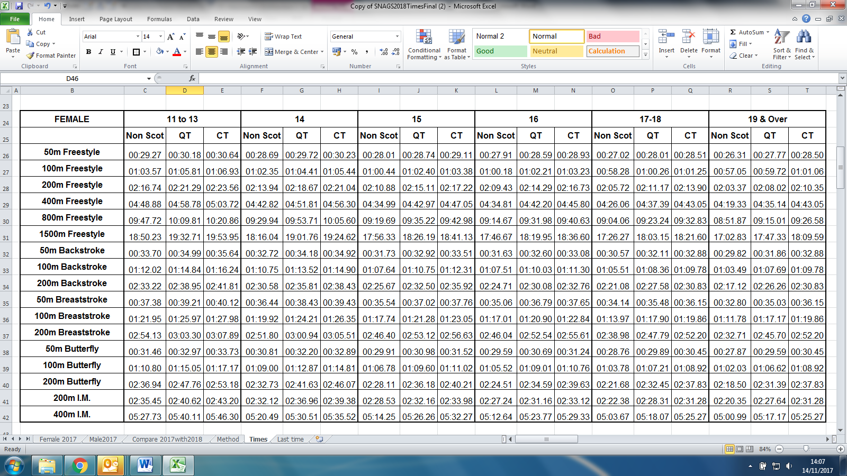

**Age as at 31st December 2018**

**ENTRIES INFORMATION**

**Making Entries**

Entries will be by computer files, which are downloadable from Swimscotland and Scottish Swimming websites. The closing date for receipt of entries is **2pm Thursday 8th March 2018.** The entry files must be e-mailed to [nationals@scottishswimming.com](mailto:nationals@scottishswimming.com). Only official files are acceptable.

**Please complete the Application Summary Sheet online by Wednesday 8th March 2018, this can be found by clicking** [**here.**](https://www.scottishswimming.com/compete/swimming/national-events/snags.aspx)

**Payment**

Payment can be made by the following options:-

* Cheque made payable to ‘SASA’ Ltd
* Card payment made by contacting Scottish Swimming Office
* BACS: Please use Ref 6012_Club The Royal Bank of Scotland, Sort Code: 832709, Account No: 00292938

Individual Events: **£9.50** Relays: **£20.00**

No entries will be accepted without the correct fee, or with the Entry Files incorrectly completed. Entry fees will not be refunded for any times submitted out-with the consideration time. No refunds will be given after the programme has been finalised.

**Entry Files**

* Entry files can be found on the SwimScotland website for download only: <http://www.swimscotland.co.uk/>
* Entries should be sent to: [nationals@scottishswimming.com](mailto:nationals@scottishswimming.com)
* The subject line **MUST** be **National Age Groups 2018 (Club Code)**
* Please ensure that you request a read receipt, if you wish confirmation of entries being received
* The summary sheet and proof of entry time report should be returned with the entry file
* Link to Hy-Tek website for Team Manager Lite, should you not have a copy of Team Manager

<http://www.hy-tekltd.com/downloads.html> Select Team Manager, then Lite

* **The closing date for receipt of entries is 14.00 on Thursday 8th March 2018**

**Team Entries**

There is no restriction on the number of teams clubs may enter. If it becomes necessary to restrict the number of entries received, teams will be selected on a time basis whether they are A or B teams.

**Please Note:** include all relay swimmers who have not been entered in individual events on to the originally submitted HyTek file. (This is to ensure that you are issued with the required number of swimmer passes and to ensure a more streamlined process on the day). Failure to do this may result in your relay team being unable to compete.

Please submit individual accredited times for each team member and reserves. The submitted relay entry time should be the sum of the accredited times for each provisional team member.

**Changes to Relay Teams**

Changes can be made up to 1 hour prior to the start of the appropriate session on team line forms and handed to the Recorder’s Desk. After this time, no changes to swim order or swimmers shall be permitted except in the event of medical emergency.

**Website Information**

* As soon as possible after closing date, an entry list will be posted on the website for clubs to check <http://www.swimscotland.co.uk> (there will be a time limit on returns)
* Any queries from the entry list should be directed to [nationals@scottishswimming.com](mailto:nationals@scottishswimming.com)
* A draft programme will then be posted on the SwimScotland <http://www.swimscotland.co.uk> and Scottish Swimming <http://www.scottishswimming.com/compete/swimming/national-events.aspx> websites.
* Please note once the draft programme is posted no subsequent updates will be shown.

**WITHDRAWALS/GENERAL INFORMATION**

**Heats**

Any withdrawals (including reserves) or amendments prior to the first day of the Championships should be notified to [agegroupswithdrawals@gmail.com](mailto:agegroupswithdrawals@gmail.com) by email providing full details (Name, Event No. entry time and Event rank no.) or withdrawal form.

Withdrawals for Session 1(including reserves) must be notified by email to [agegroupswithdrawals@gmail.com](mailto:agegroupswithdrawals@gmail.com) no later than **6.00pm on Tuesday 27th March 2018**. Withdrawals for Sessions 4, 7, 10 and 13 – including reserves (morning sessions) not previously notified must be lodged at the Recorder’s Desk no later than the 6.00 pm on the day prior to the event. Withdrawals for Sessions 2, 5, 8, 11 and 14 – including reserves (afternoon sessions) not previously notified must be lodged at the Recorder’s Desk no later than 10am on day of the event.

Swimmers failing to comply with the above (except in the case of a genuine illness or proven emergency) will be liable to a £10.00 fine for each inappropriate withdrawal.

**Finals**

Should you wish to withdraw from a Final (including reserves), you must inform the Recorders in writing on the appropriate form within 30 minutes of finalist’s lists having been published or announced. Swimmers who fail to appear for Finals will be fined and may be subject to further disciplinary action. A maximum of 2 reserves will be nominated for Finals.

Any competitor withdrawing from a Final in such a manner as to prevent a reserve taking part (except in the case of a genuine illness or proven emergency), shall be suspended immediately from all further events at the Championships). Where a reserve is brought in at short notice, the reserve shall occupy the vacant lane – there will be no re-seeding.

**Team withdrawals**

Withdrawals for relays swum in the morning sessions must be lodged no later than 6.00pm on the day prior to the event. Withdrawals for relays swum in the afternoon sessions must be lodged by 10.00 am on the day of the event. Withdrawals should be done at the recorders desk.

**Anti-Doping**

Please note that anti-doping may be in operation at any Scottish event. All swimmers not registered with SASA or the Amateur Swimming Association (ASA) /Welsh Amateur Swimming Association (WASA) will be required to sign an agreement to undergo tests as required in accordance with FINA Law. N.B. SASA, ASA and WASA swimmers will have signed an agreement when submitting their registration fee.

**Swimmers Passes**

All swimmers participating in the Championships will be issued with a pass which will allow them access to the changing village, designated seating areas and poolside. Within the venue, swimmers **MUST** wear their accreditation pass and have it visible at all times.

**Swimwear**

British Swimming and ASA advise that FINA BL8.1 only applies to Olympic Games and FINA events. A suit check will only be made if a World or European record is claimed. There is no requirement for officials to check that costumes are on the approved FINA list. Bylaws BL 8.2 and BL 8.3 cover our requirement for design and material.

**Please Note** – for the Heats ‘Over the Top Starts’ will be used where appropriate.

**AWARDS & PRESENTATIONS**

**Individual Awards**

Medals shall be presented as follows:

* Scottish Age Group Open Champion 1st 2nd and 3rd
* Scottish National Age Group Champion 1st (provided the individual is not also the Open Champion)
* Scottish National Age Group Champion must be a registered member of Scottish Swimming

**Special Awards**

Trophies (1 male/1 female) to be awarded to the best performance by a boy and girl aged 16 and under as at 31st December 2018, calculated on the basis of the FINA points for 1 single event.

Sharp Trophies (1 male/1female) to be awarded to the fastest boy and girl swimmer 12 years or under for the 200m Individual Medley (age as at 31st December 2018)

**Top Scottish Age Group Club Award**

Points will be calculated as follows: 1st - 13 points: 2nd – 11 points: 3rd –9 points: 4th to 10th place: 7 points down to 1 point. Relays will be awarded points as follows: 1st – 26 points: 2nd – 22 points: 3rd – 18 points: 4th to 10th place: 14 points down to 2 points. Please see below conditions for this award.

* Clubs must be registered with Scottish Swimming. For the purposes of the competition, “Club” is defined as any individual or composite team registered with Scottish Swimming
* Points will be allocated to the club of representation as per the closing date for entries to the Scottish Age Group Championships
* An individual swimmer can only be counted for 1 individual event per day, using their best scoring event of each day
* Swimmers scoring points for clubs in either individual or relay events must be resident or undertake the majority of training within Scotland
* The highest scoring eligible relay team per club only will be counted for relay events
* Scores will be derived from finals (from the position finished within the final) and HDW events only
* Final points will be calculated following the completion of the last event with updates given at the end of each finals session
* The Scottish Club or Composite team with the most points earned following the completion of the final event will be presented with the “Top Age Group Club” Award
* No points shall be scored from 19 & over events
* No points shall be scored from 17 & over relays

**Presentations**

Swimmers must report to the Presentation Marshal immediately upon completing their race and picking up their dry clothes from the holding area. Appropriate clothing must be worn for the presentations. It is the responsibility of the Coach/Team Manager to ensure that medallists, or a deputy be available for presentation as per the presentation schedule, a copy of which will be included in your club envelope and posted around the pool. Failure of a swimmer or depute to attend the appropriate presentation will result in the swimmer forfeiting his/her medal.

**COACH Information**

**Training Prior to Championships**

It may be possible to arrange some training times directly with the pool on Tuesday 27th March 2018. This would be subject to availability. Please contact The Duty Manager on 0141 276 8282 at Tollcross International Swimming Centre.

**Poolside Pass Information/ Accreditation**

Coaches/team managers/chaperones who are not in possession of an annual pass may purchase an individual pass for the Championship, the fee for which is £30.00.

Lost/replacement passes will be charged a fee of £10.00 for the issue of a temporary pass.

A pass is required for any coach/chaperone/team manager wishing to be poolside, and entitles you to entry for the whole of the Meet, poolside access, start & result sheets, complimentary tea, coffee and soft drinks in the specified area. Without a valid pass any coach/chaperone/team manager will NOT be permitted on poolside.

All passes must be worn by all team personnel and made visible at all times. Passes will be available for collection from the Coaches Information Desk on or after the first day of the Championships.

**Applying for a Pass**

* All applications must be submitted online, you can find more information by following the link below:- [**http://www.scottishswimming.com/compete/swimming/national-events.aspx**](http://www.scottishswimming.com/compete/swimming/national-events.aspx)
* **Please Note: All chaperone/team manager passes must be confirmed by the Head Club/Team coach as detailed on the online application form**
* All applicants MUST be Disclosure Scotland/PVG/CRB checked through either: Scottish Swimming/Swim England/WASA. It is the responsibility of the Club/Coach to ensure that, if they require their swimmers to have coach/chaperone representation on the poolside, their application is made in good time and that the relevant PVG/Criminal Records Bureau(CRB)/Disclosure & Barring Service(DBS) forms have been completed and sent to the Scottish Swimming/Swim England/WASA office(s)
* Scottish Swimming will not issue any Coach/Chaperone Pass unless a person has a valid Disclosure Certificate/PVG/CRB through the Scottish Swimming/Swim England/WASA. In-line with current legislation, valid Disclosure Certificates/PVG/CRB from any other agency, will not be accepted. If you have any queries regarding PVG/CRB certification, please contact your Governing Body or Scottish Swimming via email to [childprotection@scottishswimming.com](mailto:childprotection@scottishswimming.com)
* Coaches/Chaperones applying for passes from outside the UK should make arrangements for their National Governing Body to forward a letter of declaration to the CEO of Scottish Swimming that all applicants have conformed with their ‘home country’s’ policy concerning child protection; Passes will not be issued without such a letter
* Applicants must submit one recent photograph (jpeg format). This can be done once the order is completed on the website. Previous applicants need not submit a photograph unless their appearance has changed dramatically or they wish to update the photograph held on file. Photographs should be taken under the same rules regarding passport photographs.
* Passes will be emailed direct to members to print themselves. Plastic wallets will be available for collection from the Coach/Swimmer Desk at our Scottish Swimming National Events

**Applications close at 2pm on the 8th March 2018**

**Please Note: Any late applications will be charged £45.00 per pass**

**EVENT REGULATIONS**

Entry and Entries to all events is expressly subject to each and all of these regulations and may, where appropriate, also require compliance with the facility provider’s regulations:

* Permission for any person to enter or to remain within the venue notwithstanding possession of any ticket by that person is at the absolute discretion of the stewards and officers of Scottish Swimming and/or any police officer.
* No guarantee can be given by Scottish Swimming that the event will take place at a particular time or any particular date and Scottish Swimming reserves the right to reschedule the event without notice and without any liability for so doing.
* In the event of postponement, cancellation or abandonment of the event, refunds if any, will be made at the absolute discretion of Scottish Swimming. Scottish Swimming will have no legal liability to make a refund or to pay any form of consequential or indirect damage such as loss of enjoyment, travel and accommodation costs.
* The following are articles, which must not be brought within the venue (glasses, fireworks, smoke canisters, air horns, flares, glass bottles, weapons of any sort). Any person in possession of such items will be refused entry at the absolute discretion of any steward or officer of Scottish Swimming and/or police officer.
* No object may be thrown by spectators within the venue.
* No foul or abusive language or other offensive words such as racial or sexual abuse may be used within venues.
* No alcohol may be consumed within events except in those areas specifically designated for such purposes and in accordance with any terms displayed in those areas.
* No person may for commercial purposes take photographs or use any video recording equipment inside events without the express written permission of Scottish Swimming. The taking of photographs or use of video equipment for non-commercial purposes is permitted subject to compliance with Scottish Swimming Guidelines with regard to video recording and zoom photography.
* Video and photographs should not be posted on unsecure social websites but may be posted on secure sections of club websites.
* Should you wish to use your mobile phone for photographic purposes on poolside the procedure above must be followed.
* No flash photography permitted at any time within the competition pool hall.
* **In order to control digital photographs, mobile phones may not be used in the changing village, toilet or shower areas**
* In the interests of Health and Safety, hot food and hot drinks must not be taken into the pool hall.
* No articles, periodicals, publications, flyers or goods of any nature may be offered either free or for sale by any persons save only Scottish Swimming within events without the express written permission of Scottish Swimming.
* Any person entering events must at all times comply with any and all instructions of any steward or officer of Scottish Swimming and/or police officer. Failure to comply within a reasonable time with any such instruction will lead to the person being invited to leave.
* No tickets may be offered for resale within events. Any such tickets offered for sale may be confiscated by any steward or officer of Scottish Swimming or any police officer.

Scottish Swimming reserves absolutely the right to eject from events any person failing to comply with each and all of the Event Regulations. **MEDIA/ PHOTOGRAPHY**

Throughout this event Scottish Swimming will have a number of authorised media partners taking static photographs and video footage. These images are intended solely for the purposes of promotion and celebration of the activitiesand may include live streaming on the internet**.** Images will be made available to our media partners and uploaded to our website and our social network sites.

All parents, competitors, coaches and volunteers are required to acknowledge this is a public event and upon entering the swimming arena this may result in the recording and publication of his/her image.

Scottish Swimming may record the competition events and general images of swimmers for the purposes of education, training, swimmer analysis, performance, development and event promotion. Scottish Swimming will hold this information on file for the use of promotion, general information and marketing. This information will not be passed on to third party media partners.

Should any competitor wish not to be photographed please complete the form below. If at any time a competitor wishes a static image to be removed from our website, 7 days’ notice must be given to Scottish Swimming after which the data will be removed.

Further guidance can be found in our Child Protection Policy.

**MEDIA/PHOTOGRAPHY REFUSAL OF CONSENT**



|  |  |
| --- | --- |
| **Event:** | **Scottish National Age Groups Meet Information**  **Tollcross International Swimming Centre, 350 Wellshot Road, Glasgow G32 7QP** |
| **Date:** | **28th March – 1st April 2018** |
| **Name of Swimmer:** |  |
| **Club:** |  |

**I refuse permission for the Official Photographer of Scottish Swimming and its media partners to take and/or publish the images of me / my child. This includes the sharing of photos/images on your website and social media sites.**

|  |  |
| --- | --- |
| **Signed**  **(Parent/Carer if aged 16 or under):** |  |
| **Print Name:** |  |
| **Date:** |  |

Scottish Swimming, University of Stirling, Stirling, FK9 4LA

Tel: 01786 466520 Email: [nationals@scottishswimming.com](mailto:nationals@scottishswimming.com)